**Activity 1: Containerize the Java (Spring boot) Application**

* Spring boot: This helps in building web based java applications with built in middleware
* Generally to extension of the java package is jar to run the spring boot application the command is java -jar <package>.jar
* Lets try to run an application spring pet clinic
* To run this application we need java 11
* when we run this application it exposes port 8080
* Manual steps

sudo apt update

sudo apt install openjdk-11-jdk -y

java -version

wget https://referenceapplicationskhaja.s3.us-west-2.amazonaws.com/spring-petclinic-2.4.2.jar

java -jar spring-petclinic-2.4.2.jar

* To access the petclinic application navigate to http://<publicip-vm&gt;:8080  
  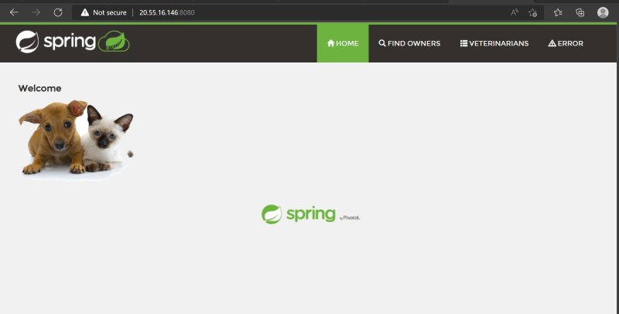

**Creating a container image using Dockerfile – Approach 1**

* <https://docs.docker.com/engine/reference/builder/> for all the Dockerfile instructions
* For this activity lets stick closer to manual approach
  + Pick a base image => ubuntu:22.04
  + spring petclinic runs on port 8080
  + Steps to install are  
    bash  
    sudo apt update  
    sudo apt install openjdk-11-jdk -y  
    wget <https://referenceapplicationskhaja.s3.us-west-2.amazonaws.com/spring-petclinic-2.4.2.jar>
  + steps to start application => java -jar spring-petclinic-2.4.2.jar
* On a highlevel to choose a base image instruction is FROM
* To execute any commands to install/configure application the instruction is RUN
* To expose the port command is EXPOSE
* To start the application when container is created the instruction is CMD
* Lets try to write a Dockerfile

FROM ubuntu:22.04

RUN apt update

RUN apt install openjdk-11-jdk wget -y

RUN wget https://referenceapplicationskhaja.s3.us-west-2.amazonaws.com/spring-petclinic-2.4.2.jar

EXPOSE 8080

CMD ["java", "-jar", "/spring-petclinic-2.4.2.jar"]

* Now create a new folder and a file with Dockerfile as a name and cpy the above contents. Create the docker image

docker image build -t spc_one:1.0 .

docker image ls

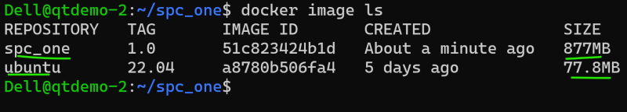  
* Lets create a container in a detached mode with name processone

docker container run -d --name processone -p 8081:8080 spc_one:1.0

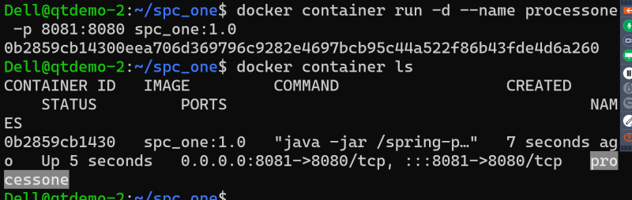  
* Now access the application http://<vm-ip&gt;:8081  
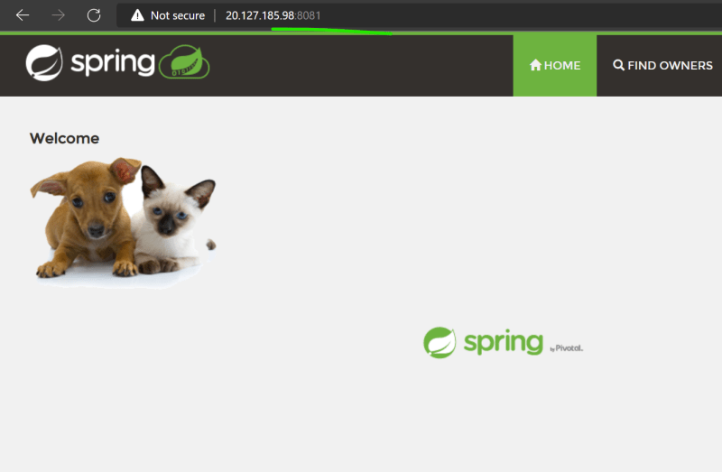

**Approach 2:**

* To run spring pet clinic i need java 11, but in the previous image i have started from ubuntu which is not necessary
* Lets use amazon correto <https://hub.docker.com/_/amazoncorretto>
* ADD instruction is used to copy the files into images

FROM amazoncorretto:11

ADD https://referenceapplicationskhaja.s3.us-west-2.amazonaws.com/spring-petclinic-2.4.2.jar /spring-petclinic-2.4.2.jar

EXPOSE 8080

CMD ["java", "-jar", "/spring-petclinic-2.4.2.jar"]

* Build the image docker image build -t spc_two:1.0 .
* list the images  
  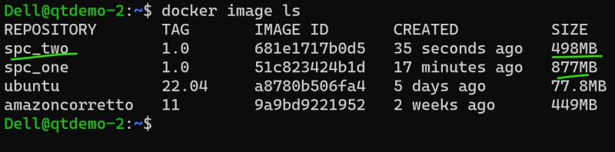
* Create the container docker container run --name processtwo -d -P spc_two:1.0  
  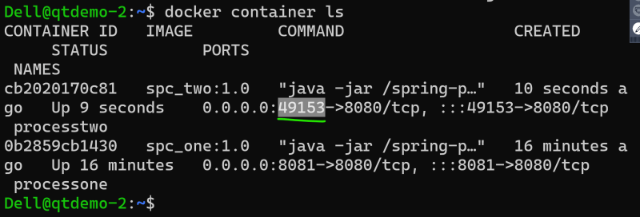
* Now access the application  
  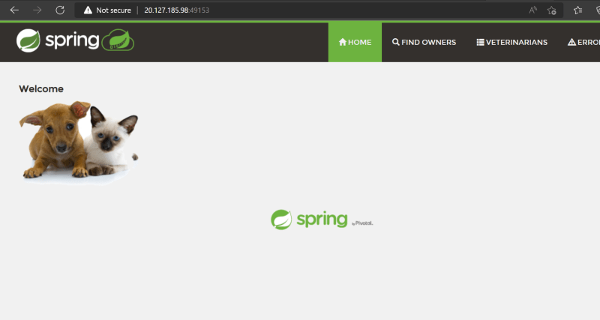
* Generally all the image publisher have slim options which further reduces the size of container on disk
* Exercise: Try using amazoncorreto:11-alpine-jdk as base image and build spc_three